Task 3 –
Feature Engineering for Model Gains
Title Page Title: Feature Engineering for Model Gains
Course: FutureXcel – Machine Learning
Week: 3
Prepared by: Mahnoor khan 2.
Introduction
The objective of this task is to apply feature engineering on the Adult Census Income dataset to improve the predictive performance of a machine learning model. Baseline model: Logistic Regression using original numeric features. Improved model: Random Forest Classifier using engineered features.
3. Dataset Overview
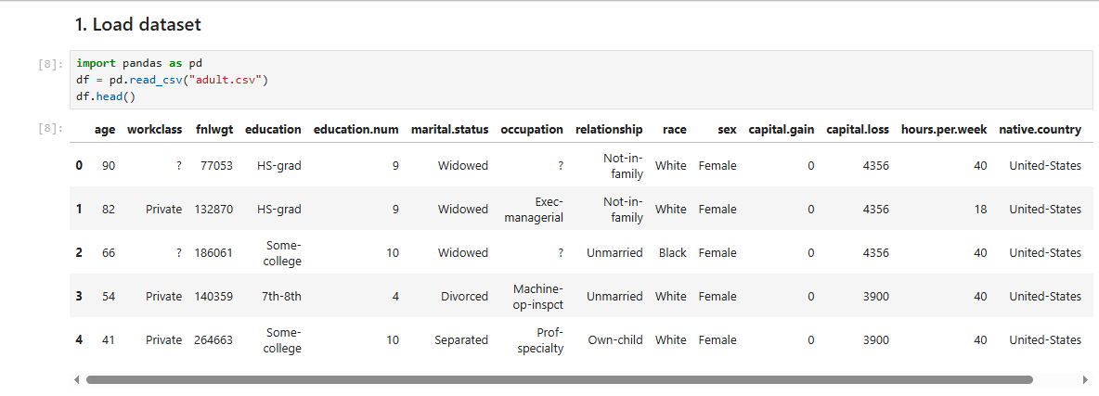Baseline Model (Before Feature Engineering) features used:
age, fnlwgt, education.num, capital.gain, capital.loss, hours.per.week Model: Logistic Regression • Train/test split: 80/20 ===Baseline Accuracy (Before FE) === Accuracy: 0.8188238906801781 5.
Feature Engineering (10 Features)
6. Improved Model (After Feature Engineering)
Features used: Original features + 10
engineered features Model: Random Forest Classifier

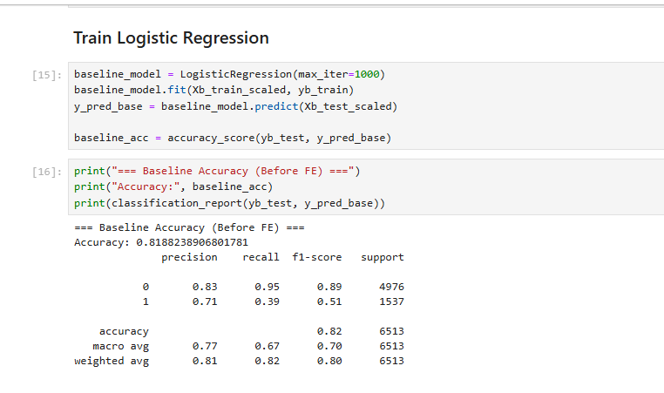4. Baseline Model (Before Feature Engineering)
Features used: age, fnlwgt, education.num, capital.gain, capital.loss, hours.per.week
Model: Logistic Regression •
Train/test split: 80/20 ===Baseline Accuracy (Before FE) === Accuracy: 0.8188238906801781
. Feature Engineering (10 Features)
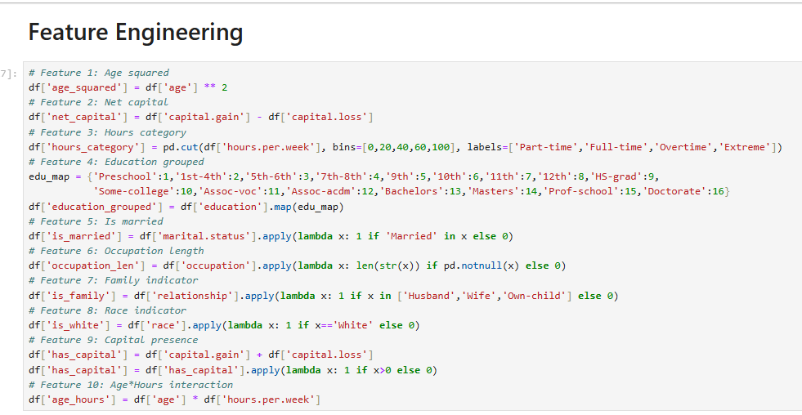(After Feature Engineeing
Improve model

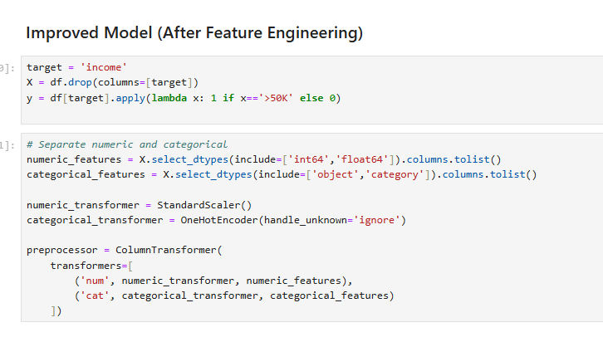tures

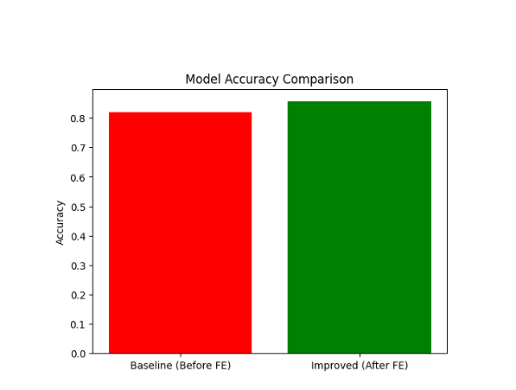

7. Comparison (Before vs After Feature Engineering)
8. Conclusion
Feature engineering improved the predictive performance of the model.
Key engineered features such as age_squared, net_capital, and age_hours contributed to better accuracy. Random Forest effectively handled non-linear relationships and categorical variables.

